**Getting Started with Jenkins 2**

# Course Overview

## Course Overview

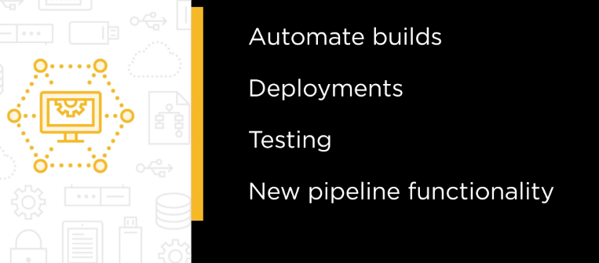

# Setting up Jenkins

## Intro

## Why Jenkins

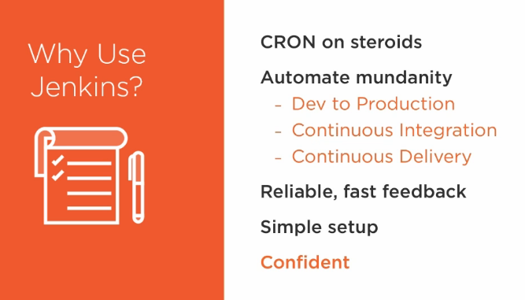

## History of Jenkins

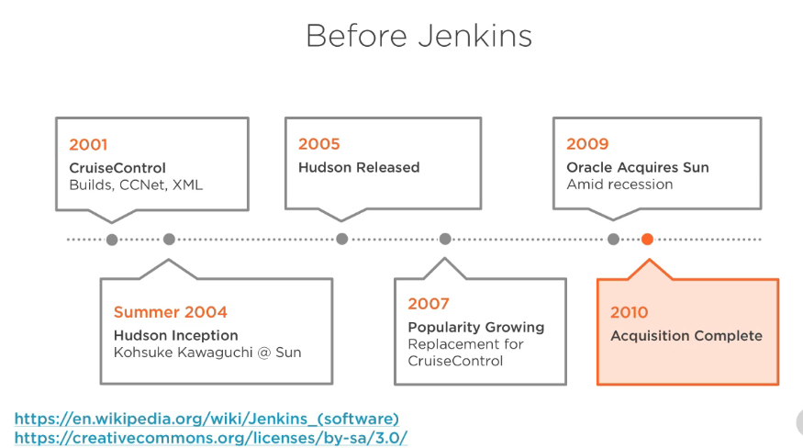

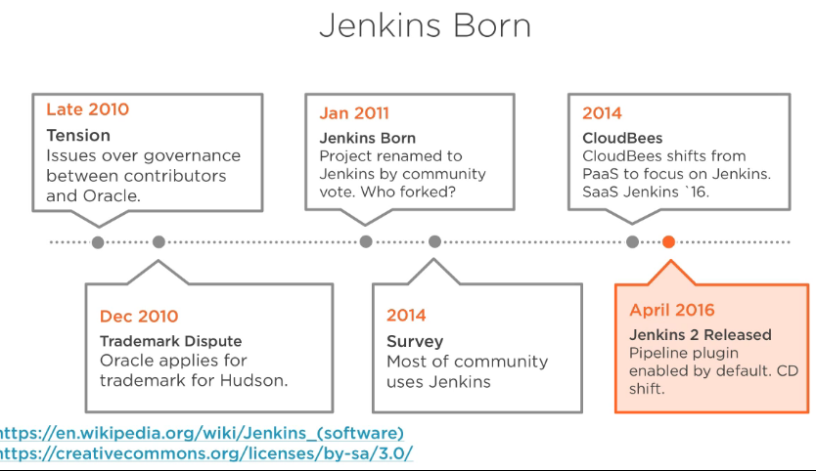

## Course Overview

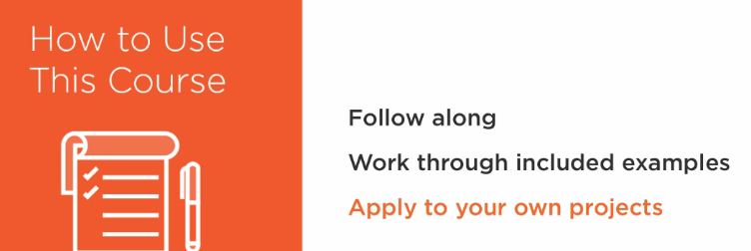

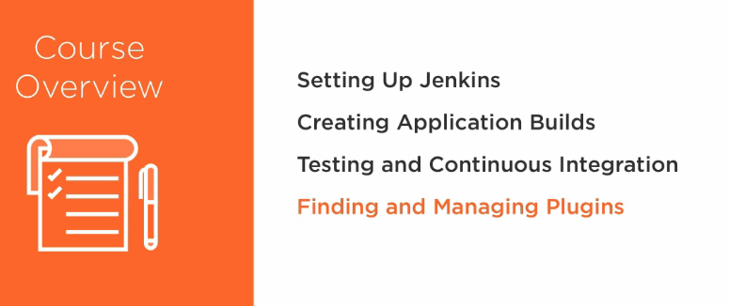

## Installing and Running Jenkins

## Initial Setup and the Data Directory

## Default Security

## Anonymous Read Access

## Running Jenkins with Docker

# Creating Application Builds

## Anatomy of the Build

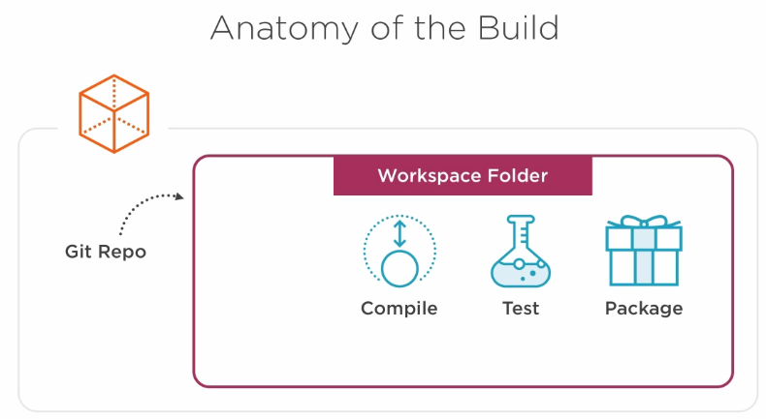

## Cloning the Sample Project

## Manual Compilation with Maven

## Manually Testing, Packaging, and Running the App

## Creating a Jenkins Job and Configuring a Git Repo

## Compiling in Jenkins

## Peeking into the Jenkins Workspace

## Browsing the Workspacre in Jenkins

## App Packaging in Jenkins

## Archiving Artifacts

## Cleaning up Past Builds

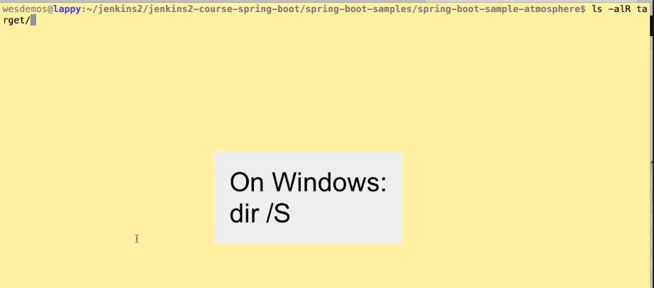

## Build Time Trend

## The Jenkins Dashboard

## Troubleshooting Build Failures

## Challenge and Importing Job config.xml Files

## Anatomy of the Job

# Testing and Continuous Integration

## Continuous Integration

## Adding Steps to Our Freestyle Project

## Creating a Pipeline Job to Execute Maven

## Archiving in a Pipeline

## Checking out a Git Repository in a Pipeline

## Changing Directories in a Pipeline

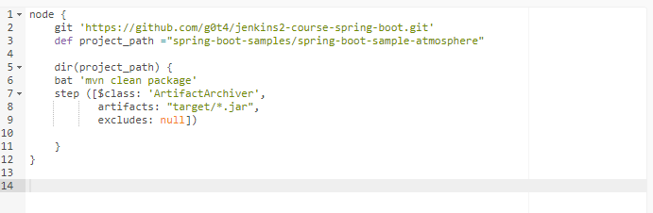

## The Master Agent Model

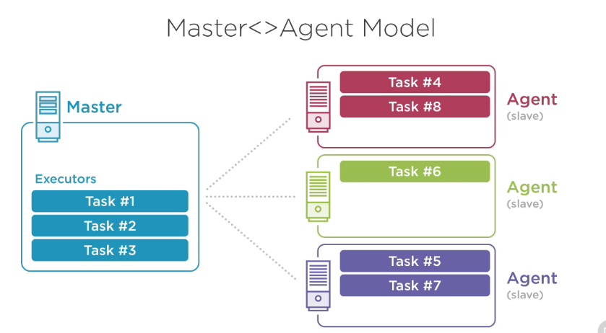

## Allocating a Node and Workspace in a Pipeline

## High-level Progress with Pipeline Stages

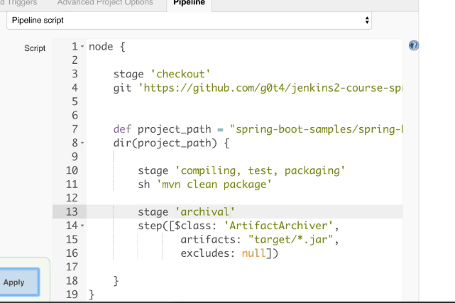

## Triggering Automatic Builds

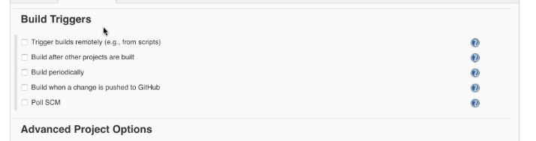

* Poll SCM: set up Jenkins to poll source code repository
* Build periodically: scheduling

## Configuring an Email Server

## Email Notification in a Pipeline

## Notifications When a Build Fails

## Duplicating a Job

## Visualizing Test Results

# Finding and Managing Plugins

## The Need for Plugins

## Integrating Code Coverage

## Assessing a Plugin

## Installing the HTML Publisher Plugin

## Publishing HTML Reports

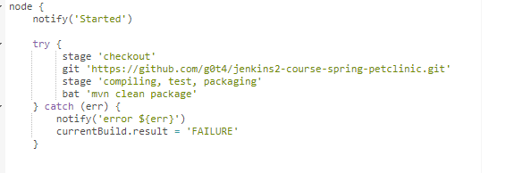

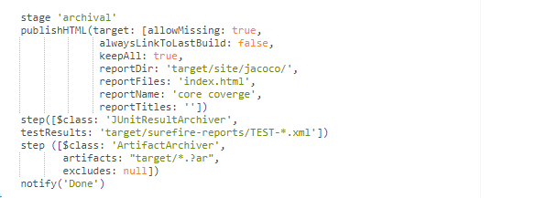

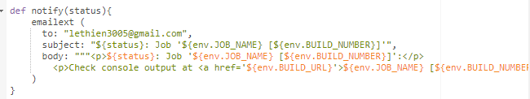

## Testing Plugins and Plugin Types

## BlueOcean UI Plugin

# Building Continuous Delivery Pipelines

## Continuous Delivery

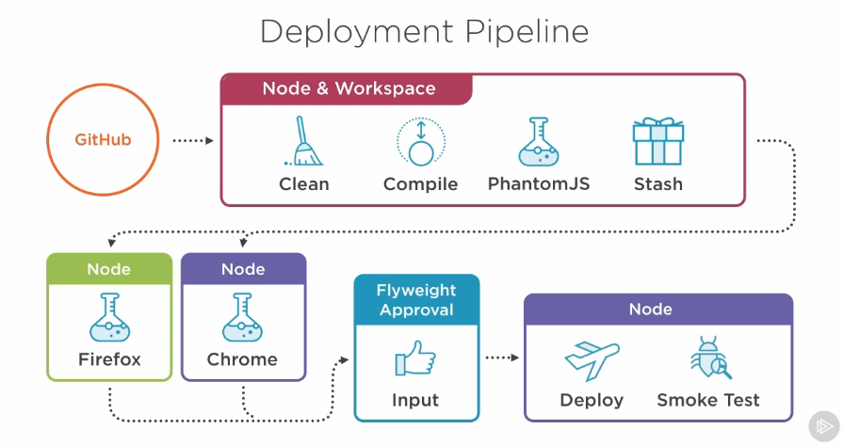

## Backup and Restore

## Following Along with Windows

## Starting Point and Pipeline Stashing

## Browsing Workspaces in Pipeline Jobs

## A Second Node Allocation

## Adding an Agent Node

## Setup Parallel Integration Testing in a Pipeline

## Executing and Monitoring Parallel Pipelines

## Manual Approval for Deployments

## Setup Deployment to Staging

## Executing a Deployment Pipeline

## Jenkinsfile - Checking the Pipeline Script into VCS

# Summary

## Why Pipeline

## Resources

## Solution to Challenge in Module 2